**PL/SQL Exercises**

* **Exercise 1: Control Structures**
* ***Scenario 1:***

The bank wants to apply a discount to loan interest rates for customers above 60 years old.

* **Question-**

Write a PL/SQL block that loops through all customers, checks their age, and if they are above 60, apply a 1% discount to their current loan interest rates.

**Code:**

BEGIN

FOR record IN (

SELECT l.LoanID

FROM Customers c

JOIN Loans l ON c.CustomerID = l.CustomerID

WHERE MONTHS_BETWEEN(SYSDATE, c.DOB) / 12 > 60

) LOOP

UPDATE Loans

SET InterestRate = InterestRate - (InterestRate * 0.01)

WHERE LoanID = record.LoanID;

END LOOP;

DBMS_OUTPUT.PUT_LINE('1% interest discount applied to customers above 60!');

END;

/

**Output:**

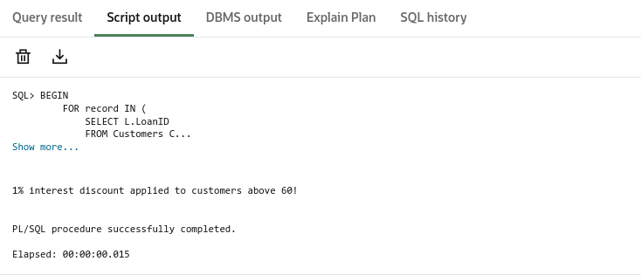

* ***Scenario 2:***

A customer can be promoted to VIP status based on their balance.

* **Question-**

Write a PL/SQL block that iterates through all customers and sets a flag IsVIP to TRUE for those with a balance over $10,000.

**Code:**

ALTER TABLE Customers

ADD IsVIP VARCHAR2(5) DEFAULT 'FALSE';

BEGIN

FOR res IN (

SELECT CustomerID, Balance

FROM Customers

) LOOP

IF res.Balance > 10000 THEN

UPDATE Customers

SET IsVIP = 'TRUE'

WHERE CustomerID = res.CustomerID;

END IF;

END LOOP;

END;

/

**Output:**

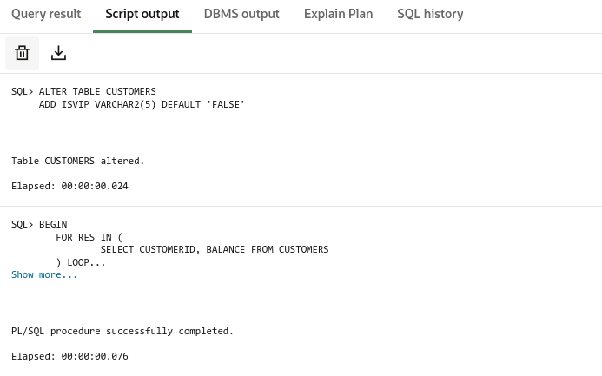

* ***Scenario 3:***

The bank wants to send reminders to customers whose loans are due within the next 30 days.

* **Question-**

Write a PL/SQL block that fetches all loans due in the next 30 days and prints a reminder message for each customer.

**Code:**

SET SERVEROUTPUT ON;

BEGIN

FOR res IN (

SELECT c.Name, c.CustomerID, l.LoanID, l.EndDate

FROM Loans l

JOIN Customers c ON c.CustomerID = l.CustomerID

WHERE l.EndDate BETWEEN SYSDATE AND SYSDATE + 30

) LOOP

DBMS_OUTPUT.PUT_LINE('Reminder: Loan ' || res.LoanID ||

' for customer ' || res.Name ||

' (Customer ID: ' || res.CustomerID || ')' ||

' is due on ' || TO_CHAR(res.EndDate, 'YYYY-MM-DD'));

END LOOP;

END;

/

**Output:**

